Let us pray for the governments around the world that they make good and wise decisions regarding food for their peoples. Heavenly Father,
ALL: strengthen us to be faithful stewards.
Let us pray for the ones who till, plant and care for the land so that there will be enough for all to eat. Heavenly Father,
ALL: strengthen us to be faithful stewards.
Heavenly Father, who has called us to be stewards of His creation and to care for it with love and compassion, help us to answer our call. Help us to tend the soil in ways that will make it last, that we might pass on these great gifts to the generations that will follow us. Heavenly Father,
ALL: strengthen us to be faithful stewards.
Blessing:
May the God who has ordered creation order our days as loving stewards. May His richest, and most bountiful blessings be upon you as you work in this garden at this rogationtide, that these gifts might be used to the benefit and welfare of all. In the name of the Father, the Son, and the Holy Spirit. Amen.
In the Western Church, processions to bless the crops were conducted, and included ‘beating the bounds’. The rogation themes of blessing the fields and beating the bounds were commended in the 1630s by the poet George Herbert, that epitome of English country parsons. He said that processions should be encouraged for four reasons:
1 A Blessing of God for the fruits of the field;
2 Justice in the preservation of bounds;
3 Charity in walking and neighbourly accompanying one another with reconciling of differences if there be any.
4 Mercy, in relieving the poor by a liberal distribution of largesse, which at the time is or ought to be used.
Contemporary concerns will include:
1 The enjoyment by all of, and access to, the countryside.
2 Conservation of species not directly offering economic profit to the owner or occupier of the land where they flourish.
3 The ecological insight of the inter-relatedness of the created order.
4 Reflection upon our relationship to the natural order: what does it mean to "have dominion" under God over the fish in the sea, the birds of the air, the cattle, the wild animals, and the reptiles, the plants bearing seed, the trees bearing fruit, the green plants?
5 The relief of the poor.

Rogation Garden Blessing

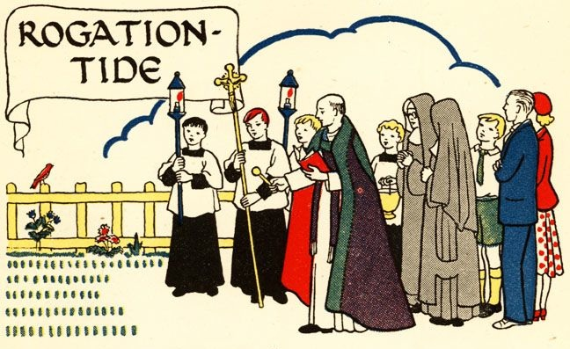

Sentences:
- The earth brought forth vegetation, plants yielding seed according to their own kinds, and trees bearing fruit in which is their seed, each according to his kind. And God saw that it was good.
- While the earth endures, seed time and harvest, cold and heat, summer and winter, day and night, shall not cease.
- And other seed fell into good soil and brought forth grain, growing up and increasing and yielding thirty fold and sixty fold and a hundred-fold.

First Station:
O all ye works of the Lord, bless ye the Lord:
O ye angels of the Lord, bless ye the Lord:
O ye heavens, bless ye the Lord:
All) Praise him and magnify him forever.
O ye waters that be above the firmament, bless ye the Lord:
O all ye powers of the Lord, bless ye the Lord:
O ye sun and moon, bless ye the Lord:
All) Praise him and magnify him forever.
Prayer for Seeds:
Heavenly Father, who has given seed to the sower and bread to the people: nourish, protect, and bless the seeds which thy people sown in hope. By thy loving and bountiful giving, may they bring forth their fruit in due season: through Jesus Christ our Lord. Amen.
Second Station:
O ye stars of heaven, bless ye the Lord:
O ye showers and dew, bless ye the Lord:
O ye winds of God, bless ye the Lord:
All) Praise him and magnify him forever.
O ye fire and heat, bless ye the Lord:
O ye Winter and Summer, bless ye the Lord:
O ye dews and frosts, bless ye the Lord:
All) Praise him and magnify him forever.
Prayer for Soil:
Heavenly Father, we give thee thanks that in the richness of the soil, nature awakens to your call of spring. We ask that thou mightest help us to be good stewards of this land: in the name of the one who gives us new life, Jesus Christ our Lord. Amen.
Third Station:
O ye frosts and cold, bless ye the Lord:
O ye ice and snow, bless ye the Lord:
O ye nights and days, bless ye the Lord:
All) Praise him and magnify him forever.
O ye light and darkness, bless ye the Lord:
O ye lightnings and clouds, bless ye the Lord:
O let the earth bless the Lord:
All) Praise him and magnify him forever.
Prayer for Sun & Rain
Heavenly Father, we receive the fruits of the earth from thee. We ask that the sun and rain come as often as they are needed so that the crops may flourish and the coming harvest be indeed bountiful Amen.
Fourth Station:
O ye mountains and hills, bless ye the Lord:
O all ye green things upon the earth, bless ye the Lord:
O ye wells, bless the Lord:
All) Praise him and magnify him forever.
Prayer for our Stewardship:
Heavenly Father, who hast made our world and all that is in it. We give thee thanks for the glories that thou hast presented to us as stewards of this earth. We ask for thy guidance as we enter a new season of growing, that we may work the land carefully and with the love of thy creation; through Jesus Christ our Lord, Amen.
Let us pray to the God who has created us and all that exists in this world saying: Heavenly Father,
ALL: strengthen us to be faithful stewards.
Let us pray for those people in the world and in our community who go hungry every day, for the children who have not known the taste of bread. Heavenly Father,
ALL: strengthen us to be faithful stewards.

