Let us pray to the God who has created us and all that exists in this world saying: Heavenly Father,
Strengthen us to be faithful stewards.
Let us pray for those people in the world and in our community who go hungry every day, for the children who have not known the taste of bread or Jesus. Heavenly Father,
Strengthen us to be faithful stewards.
Let us pray for the governments around the world that they make good and wise decisions regarding food for their people. Heavenly Father,
Strengthen us to be faithful stewards.
Let us pray for those who till, plant and care for the land so that there will be enough for all to eat. Heavenly Father,
Strengthen us to be faithful stewards.
Heavenly Father, who has called us to be stewards of your creation and to care for it and for each other, with love and compassion, help us to answer our call. Help us to tend the earthly soil and the soil of our spiritual hearts in ways that will make it last, that we might pass on these great gifts to the generations that will follow us. Heavenly Father,
Strengthen us to be faithful stewards. Amen.

Blessing

In the Western Church, processions to bless the crops were conducted, and included ‘beating the bounds’. The rogation themes of blessing the fields and beating the bounds were commended in the 1630s by the poet George Herbert, that epitome of English country parsons. He said that processions should be encouraged for four reasons:
1) A Blessing of God for the fruits of the field; 2) Justice in the preservation of bounds; 3) Charity in walking and neighbourly accompanying one another with reconciling of differences if there be any; 4) Mercy, in relieving the poor by a liberal distribution of largesse, which at the time is or ought to be used.
Contemporary concerns will include: 1) The enjoyment by all of, and access to, the countryside; 2) Conservation of species not directly offering economic profit to the owner or occupier of the land where they flourish; 3) The ecological insight of the inter-relatedness of the created order; 4) Reflection upon our relationship to the natural order: what does it mean to "have dominion" under God over the fish in the sea, the birds of the air, the cattle, the wild animals, and the reptiles, the plants bearing seed, the trees bearing fruit, the green plants? 5) The relief of the poor.
Rogation Blessing

Clergy Day – May 4, 2023
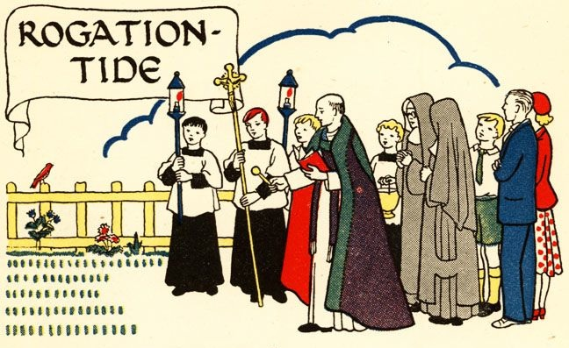

God Has Got A Garden

God has got a garden Love and Peace
Growing up inside us Generosity
From the Holy Spirit comes Self-Control and Kindness
Fruit to bless everyone Faithfulness and Patience
Gentleness and Joy
(Lyrics & Music by The Rev’d Rob Montgomery)

Sentences
- The earth brought forth vegetation: plants yielding seed of every kind, and trees of every kind bearing fruit with the seed in it. And God saw that it was good. _{Genesis 1:12, NRSV}
- Proclaim the Gospel of Jesus Christ, for the making of disciples Camp Medley’s Mission Statement

Invocation
Glorify the Lord, all you works of the Lord,
Praise him and highly exalt him for ever.
In the firmament of his power, glorify the Lord,
Praise him and highly exalt him for ever.

The Cosmic Order (at the water’s edge)
Glorify the Lord, you angels and all powers of the Lord,
O heavens and all waters above the heavens.
Sun and moon and stars of the sky, glorify the Lord,
Praise him and highly exalt him for ever.

Every shower of rain and fall of dew,
All winds and fire and heat.
Winter and summer, glorify the Lord,
Praise him and highly exalt him for ever.

O chill and cold,
Drops of dew and flakes of snow.
Frost and cold, ice and sleet, glorify the Lord,
Praise him and highly exalt him for ever.

O nights and days,
O shining light and enfolding dark.
Storm clouds and thunderbolts, glorify the Lord.
Praise him and highly exalt him for ever.

Prayer for Soil:
Heavenly Father, we give you thanks that in the richness of the soil, nature awakens to your call of spring. We ask that you might help us to be good stewards of this land, providing an awe-inspiring environment where campers play in the beauty of God’s creation: in the name of the one who gives us new life, Jesus Christ our Lord. Amen.

The Earth and its Creatures (at the edge of the woods)
Let the earth glorify the Lord,
O mountains and hills,
And all that grows upon the earth, glorify the Lord,
Praise him and highly exalt him for ever.

O springs of water, seas, and streams,
O whales and all that move in the waters.
All birds of the air, glorify the Lord,
Praise him and highly exalt him for ever.

O beasts of the wild,
And all you flocks and herds.
O men and women everywhere, glorify the Lord,
Praise him and highly exalt him for ever.
Prayer for Seeds:
Heavenly Father, who has given seed to the sower and bread to the people: nourish, protect, and bless the seeds which will be sown in hope. That all earthly life may flourish. That the spiritual lives of the campers, staff and the people they go back to may be nurtured throughout the year. By your loving and bountiful giving, may they bear their fruit in due season: through Jesus Christ our Lord. Amen.

The People of God (on the field)
Let the people of God glorify the Lord,
O priests and servants of the Lord,
O spirits and souls of the righteous, glorify the Lord,
Praise him and highly exalt him for ever.

You that are holy and humble of heart, glorify the Lord,
Praise him and highly exalt him for ever.
Prayer for our Stewardship:
Heavenly Father, who has made our world and all that is in it. We give you thanks for the glories that you have presented to us as stewards of this earth. We ask for your guidance as we enter a new season of growing and camping ministries, that we may work the land carefully and with the love of your creation. May all here be supported to learn and build important relationships with creation, in this place, each other and with God; through Jesus Christ our Lord, Amen.

Doxology
Let us glorify the Lord: Father, Son and Holy Spirit;
Praise him and highly exalt him for ever.
In the firmament of his power, glorify the Lord,
Praise him and highly exalt him for ever.

